**Adding an Employee to your Company Record**

*You must be a Company Administrator to perform this  
  
*You will need the students or parent/guardian email address to create the record. **Please use the students email if possible.**

1. Login into Member Central



1. Click on Company Management

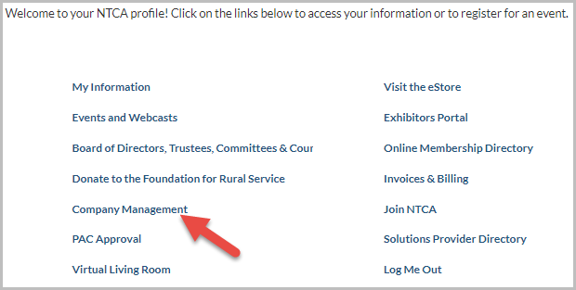

1. Click on Manage Employees

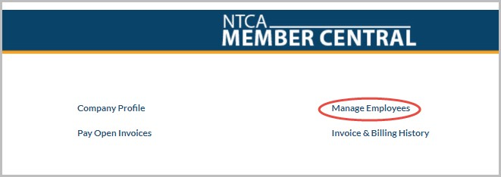

1. Scroll to the bottom of the page and select Add a New Employee



1. Complete the employee information page
2. Enter the Prefix, First Name and Last Name
3. Enter the student’s email. If the student does not have an email please suggest they create a free one. As a last resort, please use a parent/guardian email.
4. Enter ‘Student’ in the Title box. You can leave the start and end dates blank

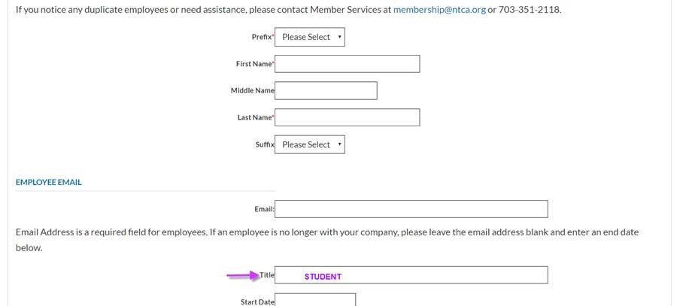

*The process is the same for chaperones. Please chose/enter chaperone rather than student. *

1. You can enter the students address or you can leave it blank and it will auto fill with the company’s address. Students/chaperones will be required to enter their address later.
2. Under employee roles select ‘student’
3. Select Save
4. Notify the student or chaperone that their account has been created and direct them to the [FRS youth tour webpage](https://www.frs.org/programs/youth-programs/youth-tour). Advise them to go the ‘Resources You’ll Need’ section about half way down the page and to select the student or chaperone information packet links.

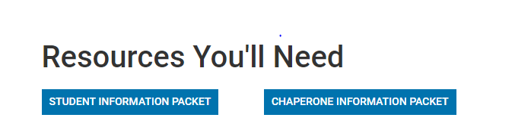

1. The students and chaperones will be redirected to the login page for the information packets. They will need to select *Forgot Password* to receive a reset password email link. They must use the email address that was used to create their account.
2. After resetting their password, they will be able to return to the login page and complete their information packets.

If student or chaperones have questions, please feel free to share our contact information [foundation@frs.org](mailto:foundation@frs.org) or they can contact me directly at [bstreauslin@frs.org](mailto:bstreauslin@frs.org) or 703-351-2026.